MACT 4233: Applied Multivariate Analysis
PCA and MDS of the Glass Identification Data
Project Report by Youssef Sarofeem 900237960
Dataset | Glass Identification Database
Methods | Classical PCA, BACON, BACON-clean robust PCA, classical MDS
Observations | 214 complete observations
Analysis variables | RI, Na, Mg, Al, Si, K, Ca, Ba, Fe
Class variable | Glass Type: 1, 2, 3, 5, 6, 7

1 Introduction and Statement of the Problem
Previous work used the Glass Identification data for classification. This report uses the nine chemical measurements to study dimensionality. PCA summarizes correlated variables into uncorrelated components, while MDS summarizes distances between glass observations.
The project applies PCA and MDS to the full data, identifies BACON outliers within each glass type, repeats PCA and MDS after removing those outliers, and compares the results.

2 Data Description
The file Youssefdat.xlsx, sheet GlassData, contains 214 complete glass samples. Type is used for coloring and summaries, but the analysis uses only the nine numeric variables: RI, Na, Mg, Al, Si, K, Ca, Ba, and Fe.
Table 1: Variables recorded in the Glass Identification dataset
Variable | Description | Type | Unit
Id | Record identifier | Identifier | -
Type | Glass type | Nominal | Category
RI | Refractive index | Continuous | Unitless
Na | Sodium | Continuous | Weight % oxide
Mg | Magnesium | Continuous | Weight % oxide
Al | Aluminum | Continuous | Weight % oxide
Si | Silicon | Continuous | Weight % oxide
K | Potassium | Continuous | Weight % oxide
Ca | Calcium | Continuous | Weight % oxide
Ba | Barium | Continuous | Weight % oxide
Fe | Iron | Continuous | Weight % oxide
Six glass classes are present: Types 1, 2, 3, 5, 6, and 7. Type 4 is not represented. All nine measurement variables are standardized because they use different scales.

3 Classical PCA (Non-Robust)

3.1 Scaling and pairwise relationships
The pairwise plot shows overlapping information among the variables. The clearest relationship is the positive RI-Ca relationship (r = 0.81). Mg is negatively related to Al and Ba.
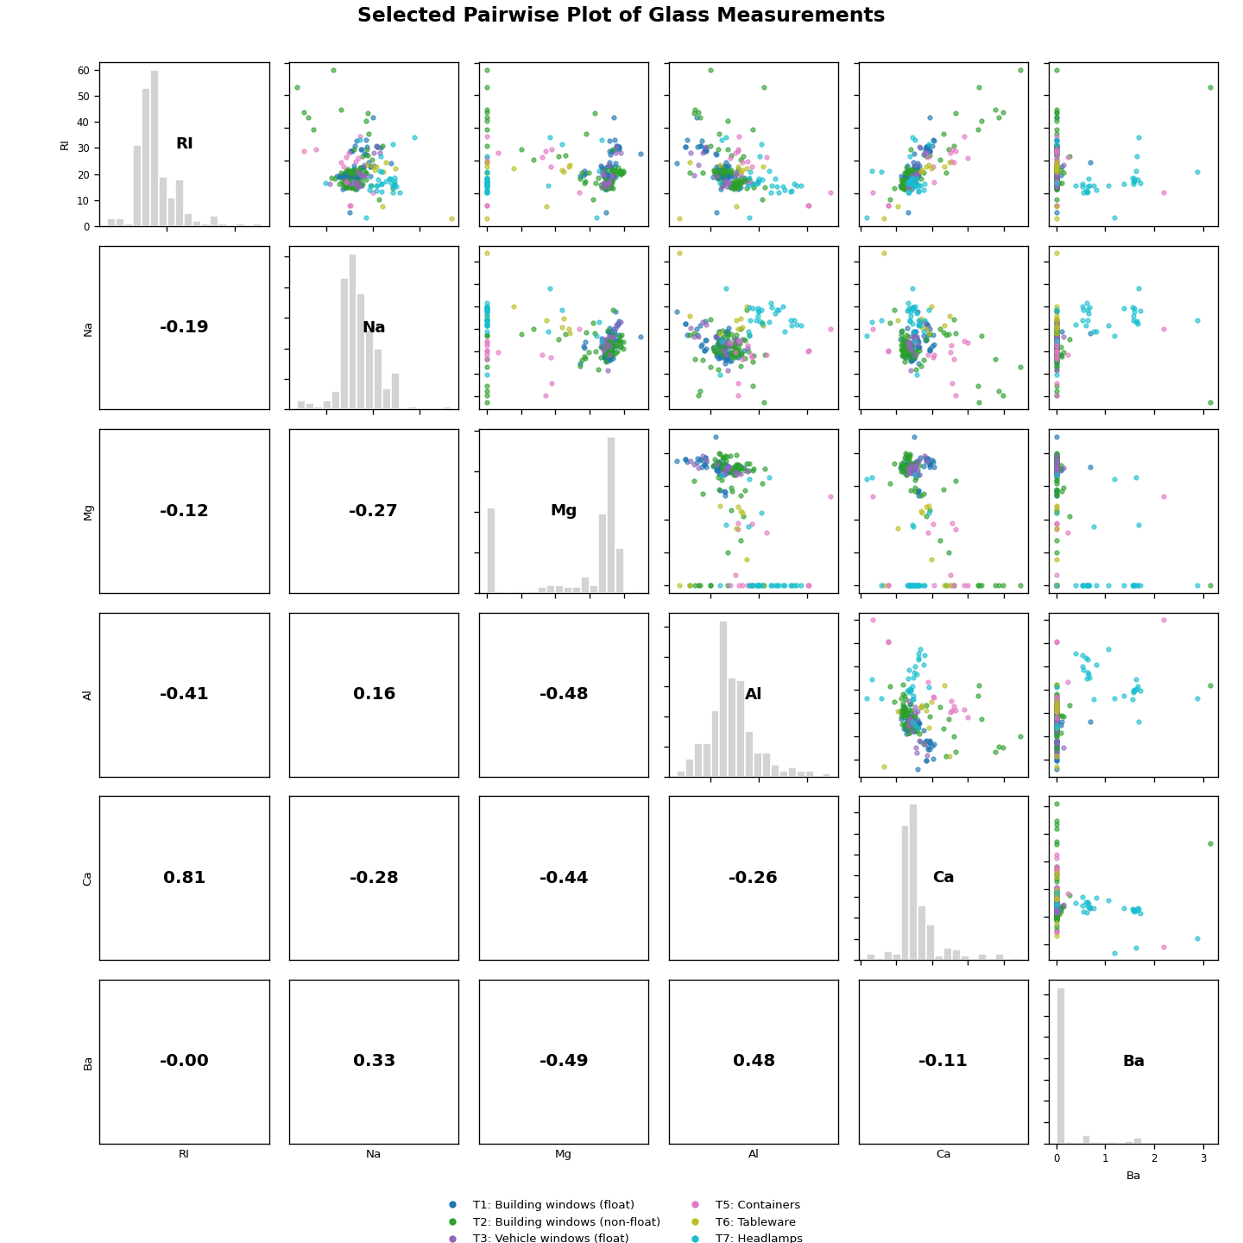
Figure 1: Selected pairwise plot of glass measurements before PCA.

3.2 Classical PCA numeric and graphical output
Classical PCA was fitted to the standardized 214 x 9 data matrix. The first four PCs explain 79.15% of the variance. Six PCs are needed to exceed 95%.
Table 2: Classical PCA variances, proportions, and cumulative proportions
Component | Standard deviation | Variance (eigenvalue) | Proportion | Cumulative
Comp.1 | 1.5847 | 2.5112 | 0.2790 | 0.2790
Comp.2 | 1.4318 | 2.0501 | 0.2278 | 0.5068
Comp.3 | 1.1853 | 1.4048 | 0.1561 | 0.6629
Comp.4 | 1.0760 | 1.1579 | 0.1287 | 0.7915
Comp.5 | 0.9560 | 0.9140 | 0.1016 | 0.8931
Comp.6 | 0.7264 | 0.5276 | 0.0586 | 0.9517
Comp.7 | 0.6074 | 0.3690 | 0.0410 | 0.9927
Comp.8 | 0.2527 | 0.0639 | 0.0071 | 0.9998
Comp.9 | 0.0401 | 0.0016 | 0.0002 | 1.0000
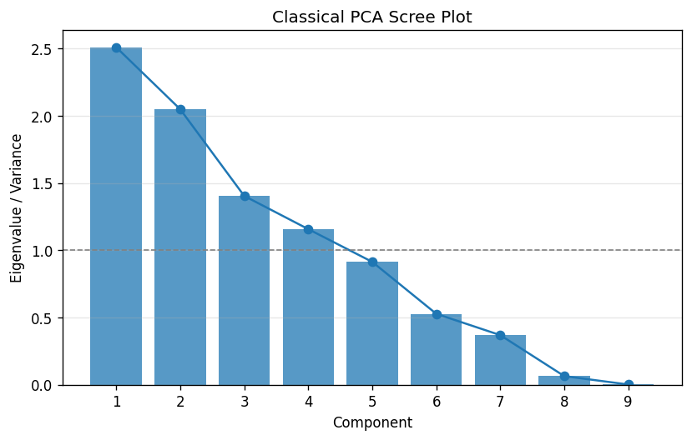
Figure 2: Classical PCA scree plot. The dashed line marks eigenvalue = 1.

3.3 Number of components to retain
Table 3: Classical PCA component-retention decisions
Rule | Decision criterion | Result
Eigenvalue rule | Keep components with eigenvalue at least 1 | 4 components (PC1-PC4)
Scree plot | Look for the elbow where eigenvalues start flattening | About 4 components
Cumulative explained variance | Keep enough components to explain at least 95% | 6 components (cumulative = 0.9517)
The eigenvalue rule and scree plot suggest about four PCs. The 95% cumulative rule requires six PCs, so six are retained when the goal is high variance preservation.

3.4 Interpretation of pc$loadings, cor(pc$scores), and cov(pc$scores)
The loadings show how each PC is built from the original variables. PC1 mainly contrasts RI and Ca with Al and Ba. PC2 is mainly a Mg direction opposite Ba and Ca. PC5 is dominated by Fe.
Table 4: Classical PCA loadings for the first six components
Variable | PC1 | PC2 | PC3 | PC4 | PC5 | PC6
RI | 0.545 | -0.286 | 0.087 | -0.147 | -0.074 | 0.115
Na | -0.258 | -0.270 | -0.385 | -0.491 | 0.154 | -0.558
Mg | 0.111 | 0.594 | 0.008 | -0.379 | 0.124 | 0.308
Al | -0.429 | -0.295 | 0.329 | 0.138 | 0.014 | -0.019
Si | -0.229 | 0.155 | -0.459 | 0.653 | 0.009 | 0.086
K | -0.219 | 0.154 | 0.663 | 0.039 | -0.307 | -0.244
Ca | 0.492 | -0.345 | -0.001 | 0.276 | -0.188 | -0.149
Ba | -0.250 | -0.485 | 0.074 | -0.133 | 0.251 | 0.657
Fe | 0.186 | 0.062 | 0.284 | 0.230 | 0.873 | -0.243
The score correlations are essentially zero, and the score covariance matrix is diagonal. This confirms the usual PCA result that the component scores are uncorrelated.
Table 5: cor(pc$scores) for the first six classical components
 | PC1 | PC2 | PC3 | PC4 | PC5 | PC6
PC1 | 1.000 | 0.000 | 0.000 | 0.000 | -0.000 | -0.000
PC2 | 0.000 | 1.000 | -0.000 | 0.000 | -0.000 | -0.000
PC3 | 0.000 | -0.000 | 1.000 | 0.000 | -0.000 | -0.000
PC4 | 0.000 | 0.000 | 0.000 | 1.000 | -0.000 | -0.000
PC5 | -0.000 | -0.000 | -0.000 | -0.000 | 1.000 | -0.000
PC6 | -0.000 | -0.000 | -0.000 | -0.000 | -0.000 | 1.000
Table 6: cov(pc$scores) for the first six classical components
 | PC1 | PC2 | PC3 | PC4 | PC5 | PC6
PC1 | 2.511 | 0.000 | 0.000 | 0.000 | -0.000 | -0.000
PC2 | 0.000 | 2.050 | -0.000 | 0.000 | -0.000 | -0.000
PC3 | 0.000 | -0.000 | 1.405 | 0.000 | -0.000 | -0.000
PC4 | 0.000 | 0.000 | 0.000 | 1.158 | -0.000 | -0.000
PC5 | -0.000 | -0.000 | -0.000 | -0.000 | 0.914 | -0.000
PC6 | -0.000 | -0.000 | -0.000 | -0.000 | -0.000 | 0.528
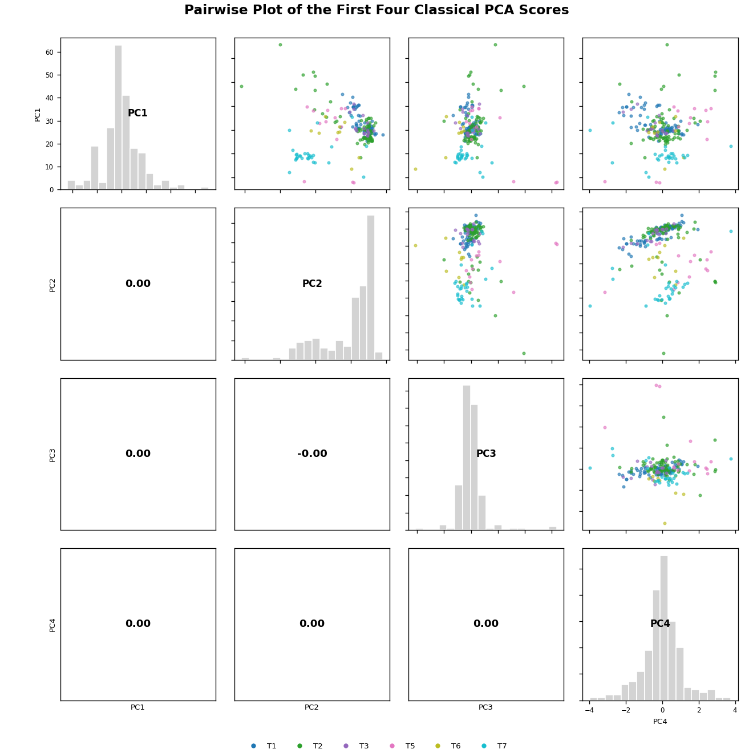
Figure 3: Pairwise plot of the first four PCA scores. The near-zero lower-triangle correlations show orthogonality.

4 Robust PCA Using BACON

4.1 BACON outlier detection
BACON was used to find unusual observations before robust PCA. Outliers were detected within each glass type because the dataset contains several different glass groups. Fe was omitted only from the BACON step because Type 6 has only 9 observations.
Table 7: BACON outlier results by observed glass type
Class | Group size | No. outliers | Cutoff
Type 1 | 70 | 10 | 6.1784
Type 2 | 76 | 20 | 6.1080
Type 3 | 17 | 0 | 9.6647
Type 5 | 13 | 3 | 13.5519
Type 6 | 9 | 0 | 46.5561
Type 7 | 29 | 8 | 9.5915
Within-class BACON flags 41 observations, leaving 173 observations for the cleaned analysis. Most outliers come from Types 2 and 7.
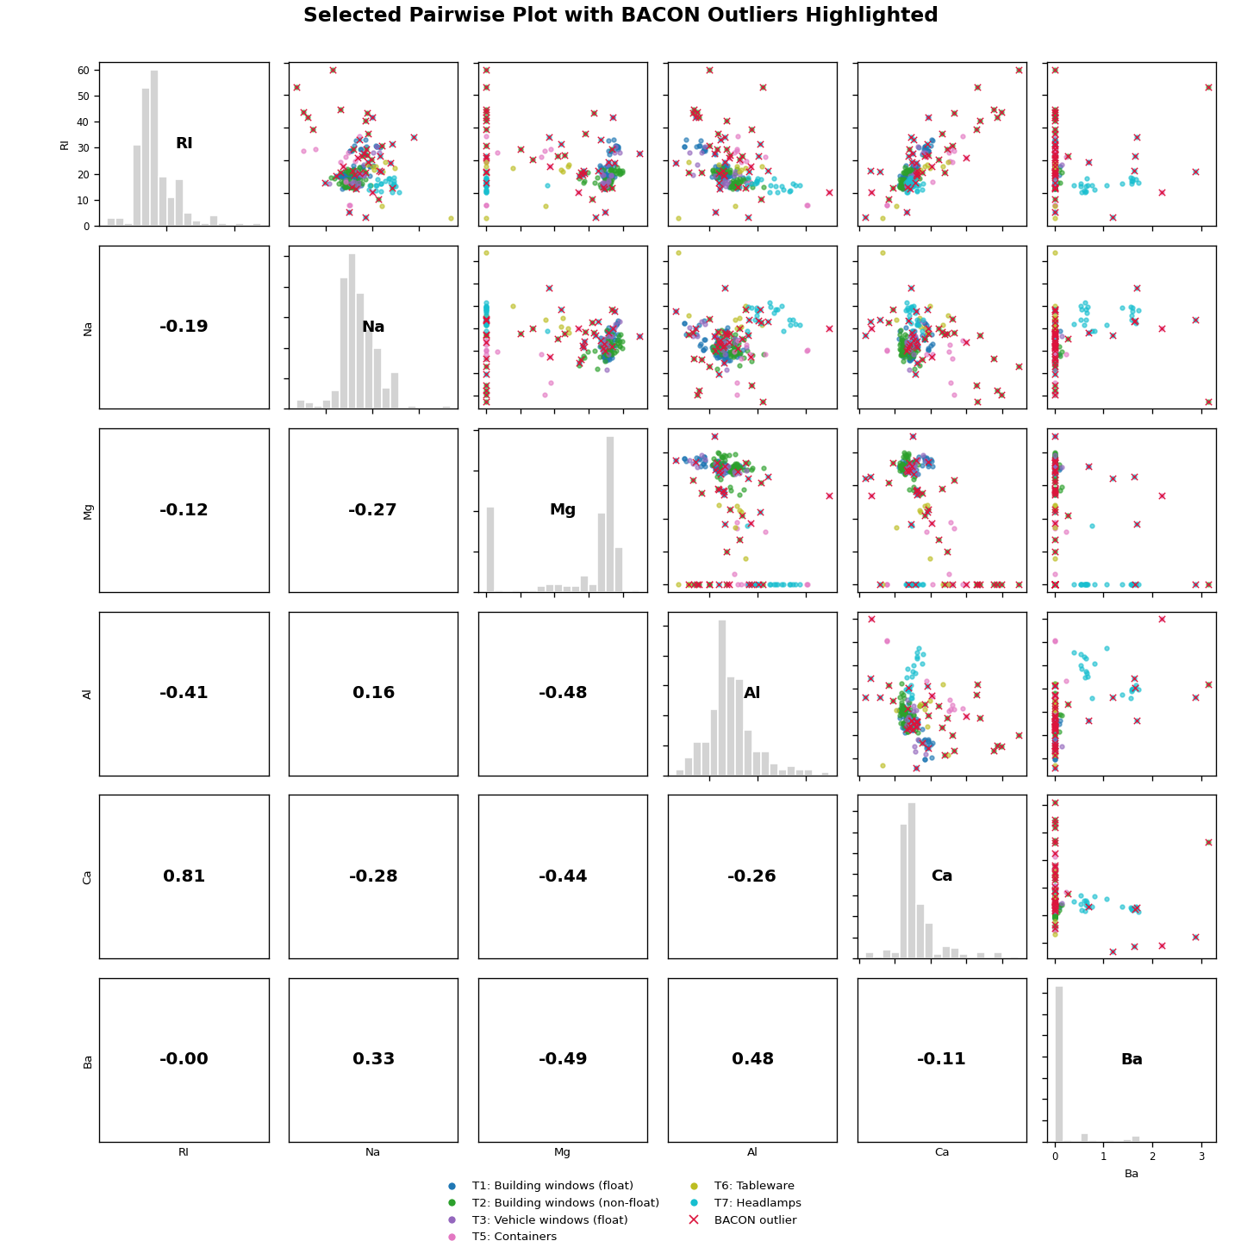
Figure 4: Selected pairwise plot with within-class BACON outliers highlighted.

4.2 BACON-clean / robust PCA output
After removing BACON outliers, PC1 explains 33.10% instead of 27.90%. The first four PCs explain 81.75%, compared with 79.15% in the full data.

Table 8: BACON-clean PCA variances, proportions, and cumulative proportions
Component | Standard deviation | Variance (eigenvalue) | Proportion | Cumulative
Comp.1 | 1.7261 | 2.9793 | 0.3310 | 0.3310
Comp.2 | 1.4409 | 2.0761 | 0.2307 | 0.5617
Comp.3 | 1.1412 | 1.3024 | 0.1447 | 0.7064
Comp.4 | 0.9999 | 0.9999 | 0.1111 | 0.8175
Comp.5 | 0.9456 | 0.8942 | 0.0994 | 0.9169
Comp.6 | 0.6410 | 0.4109 | 0.0457 | 0.9625
Comp.7 | 0.5317 | 0.2827 | 0.0314 | 0.9939
Comp.8 | 0.2282 | 0.0521 | 0.0058 | 0.9997
Comp.9 | 0.0497 | 0.0025 | 0.0003 | 1.0000
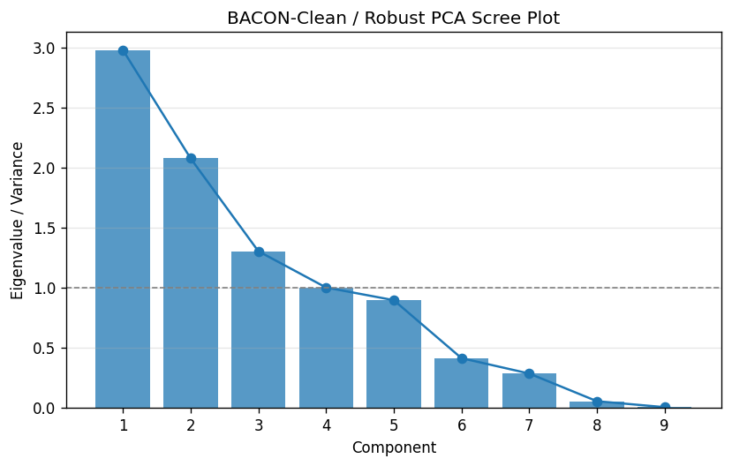
Figure 5: BACON-clean / robust PCA scree plot.
Table 9: BACON-clean PCA component-retention decisions
Rule | Decision criterion | Result
Eigenvalue rule | Keep components with eigenvalue at least 1 | 3 components (PC1-PC3)
Scree plot | Elbow after the leading components | About 3 to 4 components
Cumulative explained variance | Keep enough components to explain at least 95% | 6 components (cumulative = 0.9625)

The clean-data loadings are slightly clearer. The first clean PC contrasts Mg, RI, and Ca with Al and Ba, so outliers affected some of the original PCA structure.
Table 10: BACON-clean PCA loadings for the first six components
Variable | PC1 | PC2 | PC3 | PC4 | PC5 | PC6
RI | 0.373 | 0.483 | -0.212 | -0.045 | -0.000 | 0.148
Na | -0.333 | 0.286 | 0.067 | -0.416 | 0.490 | -0.503
Mg | 0.478 | -0.238 | 0.281 | -0.145 | 0.149 | 0.335
Al | -0.439 | -0.146 | -0.386 | 0.180 | -0.130 | 0.208
Si | -0.293 | -0.025 | 0.589 | 0.378 | -0.355 | -0.174
K | 0.024 | -0.491 | -0.545 | -0.043 | -0.081 | -0.256
Ca | 0.126 | 0.561 | -0.260 | 0.214 | -0.401 | -0.168
Ba | -0.448 | 0.224 | -0.064 | 0.025 | 0.254 | 0.650
Fe | 0.161 | -0.007 | -0.079 | 0.762 | 0.602 | -0.153

4.3 Comparison of PCA with and without outliers
Table 11: PCA comparison before and after BACON outlier removal
Analysis | n | PC1 eigenvalue | PC1 proportion | Cumulative PC1-PC2 | Cumulative PC1-PC4 | PCs for 95%
Classical PCA: full data | 214 | 2.5112 | 0.2790 | 0.5068 | 0.7915 | 6
Robust PCA: BACON-clean | 173 | 2.9793 | 0.3310 | 0.5617 | 0.8175 | 6
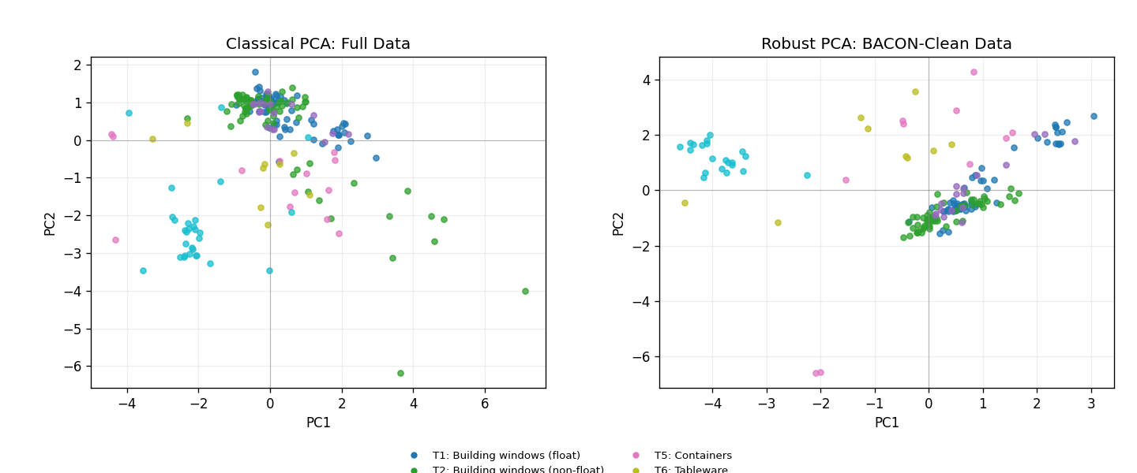
Figure 6: PC1-PC2 score plots before and after BACON cleaning.
Outlier removal strengthens the leading components, but it does not change the 95% rule result: both PCA analyses still need six PCs. A two-dimensional plot is useful visually, but it is not a full summary of the data.

5 Multidimensional Scaling (MDS)

5.1 Introduction to MDS
MDS reduces dimensionality by preserving distances between observations. Here, the standardized Euclidean distance matrix is used, then classical MDS is applied with cmdscale(d, eig = TRUE).
MDS is useful as a second check because PCA focuses on variable directions, while MDS focuses on distances between glass samples.

5.2 Classical MDS on the full data
For the full data, the variables were standardized, Euclidean distances were computed, and classical MDS was fitted. The positive eigenvalues and P_m values are shown below.
Table 12: Classical MDS positive eigenvalues for the full data
Dimension | Positive eigenvalue | Proportion | P_m
Dim.1 | 534.8856 | 0.2790 | 0.2790
Dim.2 | 436.6713 | 0.2278 | 0.5068
Dim.3 | 299.2224 | 0.1561 | 0.6629
Dim.4 | 246.6327 | 0.1287 | 0.7915
Dim.5 | 194.6820 | 0.1016 | 0.8931
Dim.6 | 112.3788 | 0.0586 | 0.9517
Dim.7 | 78.5970 | 0.0410 | 0.9927
Dim.8 | 13.6107 | 0.0071 | 0.9998
Dim.9 | 0.3408 | 0.0002 | 1.0000
The full data needs five MDS dimensions to reach P_m >= 0.80. Four dimensions are close (P_4 = 0.7915), but still slightly below the cutoff.

5.3 BACON-clean MDS
The same steps were repeated after removing the 41 BACON outliers. The cleaned data reaches P_m >= 0.80 with four dimensions.
Table 13: BACON-clean MDS positive eigenvalues
Dimension | Positive eigenvalue | Proportion | P_m
Dim.1 | 512.4396 | 0.3310 | 0.3310
Dim.2 | 357.0892 | 0.2307 | 0.5617
Dim.3 | 224.0128 | 0.1447 | 0.7064
Dim.4 | 171.9828 | 0.1111 | 0.8175
Dim.5 | 153.8024 | 0.0994 | 0.9169
Dim.6 | 70.6748 | 0.0457 | 0.9625
Dim.7 | 48.6244 | 0.0314 | 0.9939
Dim.8 | 8.9612 | 0.0058 | 0.9997
Dim.9 | 0.4300 | 0.0003 | 1.0000
Outlier removal improves the MDS representation: fewer dimensions are needed after cleaning.

5.4 MDS eigenvalue and goodness plots
The eigenvalue plots show which dimensions matter most. The goodness plots show cumulative P_m, with 0.80 used as the practical cutoff.
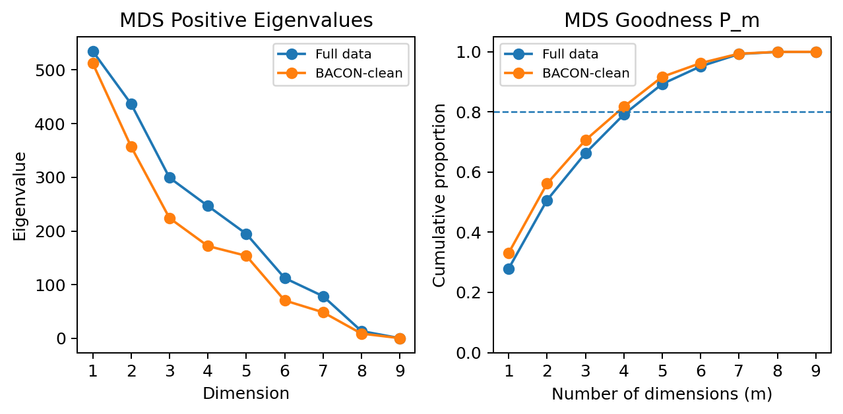
Figure 7: MDS positive eigenvalues and goodness of representation before and after BACON cleaning.
The full-data curve reaches 0.80 at m = 5. The BACON-clean curve reaches it at m = 4.
Table 14: MDS dimension-retention summary
Analysis | n | P_2 | P_4 | Dimensions for P_m >= 0.80
MDS: full data | 214 | 0.5068 | 0.7915 | 5
MDS: BACON-clean | 173 | 0.5617 | 0.8175 | 4

5.5 PCA and MDS comparison
PCA and classical MDS give similar messages because both use the same standardized Euclidean information. PCA describes variable combinations; MDS describes distances among observations.
Two dimensions are useful for visualization, but they do not represent the data well enough alone. The full data has P_2 = 0.5068, and the clean data has P_2 = 0.5617.

Figure 8: Two-dimensional PCA score maps, which have the same Euclidean geometry as classical MDS maps for the scaled data.
Table 15: Overall comparison of PCA and MDS conclusions
Method/data | Main decision | Comment
PCA: full data | 6 PCs for 95%; 4 PCs by eigenvalue/scree | The first four components explain 79.15%.
PCA: BACON-clean | 6 PCs for 95%; about 3-4 by eigenvalue/scree | The first four components improve to 81.75%.
MDS: full data | 5 dimensions for P_m >= 0.80 | Four dimensions are close but still below 0.80.
MDS: BACON-clean | 4 dimensions for P_m >= 0.80 | Removing outliers improves the distance representation.
Overall, PCA and MDS agree that the glass data are not truly two-dimensional. Outlier removal makes the leading dimensions clearer but does not remove the need for several dimensions.

6 AI Contribution to the Project
AI assistance was used as an editing and coding support tool. It helped simplify wording, organize the MDS additions, and clean the R script. The dataset choice, statistical decisions, interpretation, final checking, and responsibility for the submitted work remain my own.

7 Summary and Conclusions
This project applied PCA, BACON-clean PCA, full-data MDS, and BACON-clean MDS to the Glass Identification data.
For PCA, the full and clean datasets both need six PCs to exceed 95% variance. Cleaning mainly increases the strength of the first few components.
For MDS, the full data needs five dimensions to reach P_m >= 0.80, while the clean data needs four. Final conclusion: outliers affect the clarity of the low-dimensional structure, but the dataset still needs more than two dimensions.

Appendix A: Additional Computer Outputs
Table A1: Descriptive statistics for the PCA variables
Variable | count | mean | std | min | 25% | 50% | 75% | max
RI | 214.000 | 1.518 | 0.003 | 1.511 | 1.517 | 1.518 | 1.519 | 1.534
Na | 214.000 | 13.408 | 0.817 | 10.730 | 12.908 | 13.300 | 13.825 | 17.380
Mg | 214.000 | 2.685 | 1.442 | 0.000 | 2.115 | 3.480 | 3.600 | 4.490
Al | 214.000 | 1.445 | 0.499 | 0.290 | 1.190 | 1.360 | 1.630 | 3.500
Si | 214.000 | 72.651 | 0.775 | 69.810 | 72.280 | 72.790 | 73.088 | 75.410
K | 214.000 | 0.497 | 0.652 | 0.000 | 0.122 | 0.555 | 0.610 | 6.210
Ca | 214.000 | 8.957 | 1.423 | 5.430 | 8.240 | 8.600 | 9.172 | 16.190
Ba | 214.000 | 0.175 | 0.497 | 0.000 | 0.000 | 0.000 | 0.000 | 3.150
Fe | 214.000 | 0.057 | 0.097 | 0.000 | 0.000 | 0.000 | 0.100 | 0.510
Table A2: Strongest absolute pairwise correlations among the nine PCA variables
Variable 1 | Variable 2 | Correlation
RI | Ca | 0.810
RI | Si | -0.542
Mg | Ba | -0.492
Mg | Al | -0.482
Al | Ba | 0.479
Mg | Ca | -0.444
RI | Al | -0.407
Na | Ba | 0.327
Table A3: Union of within-class BACON outlier IDs
BACON outlier IDs
1, 22, 36, 48, 53, 54, 55, 56, 57, 62, 71, 85, 93, 103, 104, 105, 106, 107, 108, 109, 110, 111, 112, 113, 125, 128, 129, 130, 131, 132, 164, 165, 174, 186, 187, 188, 189, 190, 202, 208, 212

